

**Wabash Valley Astronomical Society, Inc.  
P.O. Box 2020  
West Lafayette, IN 47996-2020**

|  |  |  |  |  |  |  |  |
| --- | --- | --- | --- | --- | --- | --- | --- |
|  | <https://www.wvastro.org> |  |  | [/WVASstars](https://www.facebook.com/WVASstars) |  |  | [WVASinfo@gmail.com](mailto:WVASinfo@gmail.com) |

**Recommended First (or Second) Telescopes**

People who are interested in space and astronomy often ask our members for advice about which telescopes they should purchase. This document is a consolidation of telescope and related equipment used and recommended by our club members, and recommendations made by other reputable astronomy organizations. Disclaimer: The [Wabash Valley Astronomical Society](https://www.wvastro.org) (WVAS) does not endorse any sellers or specific brands of equipment other than expressing general satisfaction. However, if you’re interested in a particular telescope, you can ask our members for their individual opinions.

This document is not a tutorial on telescopes but those can be found in books, astronomy magazines, and on the internet. However, there are a few terms we’ll use that should briefly be introduced. We’ll start with the three types of telescopes you’ll most often encounter.

**Refractor telescope**: This is a classical telescope that has been used for centuries, with a convex lens in the front of a hollow tube and another lens at the rear. Refractor telescopes (AKA “refractors”) with good quality lenses will generally have the clearest images of solar system objects such as the Moon and planets, compared with reflector and Cassegrain telescope designs. However, refractors can get expensive as the aperture (diameter) increases.

**Reflector telescope:** Instead of two lenses, a Newtonian reflector telescope (AKA “reflector”) has one end open to the sky while a curved mirror sits at the bottom of the telescope tube to focus and compress incoming light. An interchangeable eyepiece (“EP”) lens is then used to view the image. This design is much less expensive than a refractor of the same “aperture” (see below). That makes it possible to buy a telescope with more aperture than a refractor at the same price, meaning that more light can be gathered for brighter images. Reflectors are the most common type of telescope used by amateurs. Deep-space objects such as star clusters, nebulae, and galaxies are generally best seen with reflectors.

**Catadioptric** **(or Compound)** **telescope:** Two mirrors and a correcting lens are used in the Catadioptric design to fold the light path, making it possible to have a shorter telescope length than a refractor or reflector of the same focal length and still have as much aperture as a reflector. This additional complexity means that the cost of a Catadioptric telescope is higher than for a reflector of the same aperture. Cassegrain and Maksutov are the most common types of catadioptric telescopes.

**Aperture:** Aperture is the diameter of the primary (front) lens on a refractor or of the curved mirror on a reflector or Cassegrain telescope. The more aperture, the more light the telescope gathers and the brighter the image will be with generally better resolution. Try to get a telescope with as much aperture as you can reasonably afford.

**Focal Length:** The distance between the primary lens or mirror of a telescope and where the light focuses (focal plane) is called the focal length. This distance is normally expressed in millimeters or inches for amateur-size telescopes.

**Focal Ratio:** Dividing a telescope’s focal length by its aperture gives its “focal ratio”. This is typically written as “f/” followed by the focal ratio value, e.g., f/6.3, f/10, etc.

**Eyepieces:** An eyepiece (“EP”) is used to view the image at the telescope’s “focal plane” (see *Focal Length*, p. 2). Each eyepiece also has a focal length, normally measured in millimeters. Dividing the telescope’s focal length by the eyepiece’s focal length gives the magnification factor, i.e., “power”.

**Mount:** The mount is what the telescope sits on. This component is as important as the telescope itself when observing. A cheap telescope on a good mount is much more usable than a good telescope on a cheap mount! The mount must be solid and as resistant to unwanted movement as possible. A wobbly mount results in jittery views through the telescope to the extent that it can be essentially unfocusable. Beware of tripods that are flimsy or shaky. The mount type also determines how the telescope is aimed. This can be either altitude-azimuth (up-down and left-right) or equatorial. Altitude-azimuth (“alt-az”) mounts are simpler and less expensive than equatorial mounts, but equatorial mounts are easier for tracking objects as they drift across the sky. A Dobsonian mount (“Dob”) uses a simple but effective alt-az design. Equatorial mounts are usually of the “German equatorial” or “fork” varieties. German equatorial mounts are more complicated to set up but they’re generally less expensive than fork mounts.

**Recommendations**

Before looking at a list of specific telescopes, we’ll start by describing a type of telescope and mount that are very popular as first or second telescopes for amateur astronomers. This is a Newtonian reflector on a Dobsonian alt-az mount. One of these with an 8-inch (203 mm) aperture is generally considered to be the “sweet spot” for amateur astronomers. They’re affordable, provide good light gathering, and are easy to set up and take down. A few useful accessories are then described followed by a list of specifically recommended telescopes of all types. The following recommendation and description is by L. Wieland, Editor, *The Nebula*, newsletter of the Wabash Valley Astronomical Society.

**Recommended Telescope & Mount Type:** Newtonian Reflector (5 to 10 inches in diameter) on a Dobsonian Mount (often lazily referred to as “Dobsonian” or “Dob” telescopes).

**Newtonian Telescope Design:**

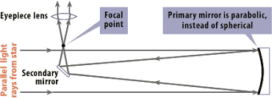

Light enters the telescope tube and hits the parabolic primary mirror at the back. The reflected light cone comes to a point where it’s narrow enough to be reflected again by a flat “secondary” mirror mounted toward the front of the telescope (at an angle of 45˚). The secondary reflects light out of the place where the eyepiece will be mounted. The simple design and minimal amount of figured and shaped glass make these telescopes less expensive than a refractor of the same aperture. **A parabolic mirror is KEY! Avoid spherical mirrors in a Newtonian reflector with a focal ratio less than f/10, especially with small aperture mirrors!**

**Dobsonian Alt-Az Mount** (as opposed to Equatorial Mount) **Design:**

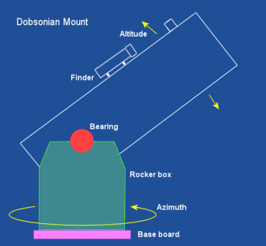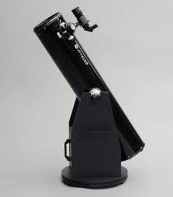

The design of the Dobsonian mount is, again, simple and, again, helps keep down the overall cost of the telescope. It is an “alt-az”, i.e., altitude-azimuth design. Altitude is how high up or down the telescope is pointed, azimuth is the horizontal angle of a compass bearing, i.e., it’s swinging the telescope to the left or right.

Rationale: The Newtonian design telescope is very simple to use and gives you LOTS of aperture for your dollar. Get one with at least a 5-inch aperture and preferably 8-inches or more if you can afford it. Like the pupil of your eye, the “aperture” (i.e., telescope diameter) is the “pupil” of the telescope and the wider it is, the more light it lets in. The more light the image on your mirror is saturated with, the more detail you will be able to see in that image because you will have more image to magnify. Magnifying the image is what eyepieces (see p. 2) do. The Dobsonian mount is great because it is rock solid, giving you stable views of an object without shaking just because you’re trying to focus. In addition, it sets up in minutes with no polar alignment necessary to begin using your telescope and searching for objects of interest.

Drawbacks of Dob mount Newtonians: Because they are not equatorially mounted, to keep the telescope aimed at an object you must constantly nudge the scope to the west and change the altitude as well. Motorized (clock) drives for both altitude and azimuth do now exist allowing this type of telescope to be used for astrophotography, but, in general, equatorial mounts are better for this application.

**Recommended Features & Accessories**

**“Ballpark Finders”: Green Laser & Red Dot**

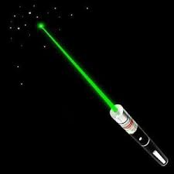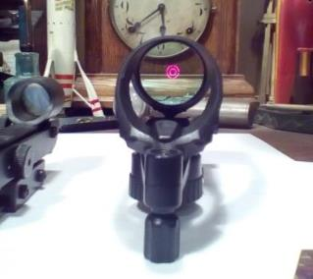

Rationale: Green Lasers and Red Dot finders allow you to rapidly get your telescope looking at the right region of sky where your object of interest resides.

**Pinpoint Finder: Right-Angle Correct-Image (RACI) Finder**

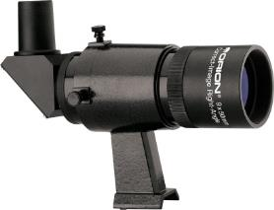

Rationale: An image-correcting right-angle finder is a great help for locating objects of interest in the sky because you can use it to develop “star hops” to find things. They do not help you get in the ballpark of a given object; a green laser can be used for that and others might use a red dot finder or Telrad, but the RACI finder helps you fine-tune finding anything in the sky. The right angle of the finder’s eyepiece allows you to remain in a comfortable position while searching for objects. Try to imagine using a straight-through finder for an object close to the “zenith” (i.e., almost straight up). With a straight-through finder you’ll be crouched against the ground, squinting up through a tiny eyepiece trying to see the sky or craning your neck. Not fun. The image correcting feature allows you to use your star maps without losing your mind trying to figure out where to go in a through-the-looking-glass backwards world.

**Crayford Focuser**

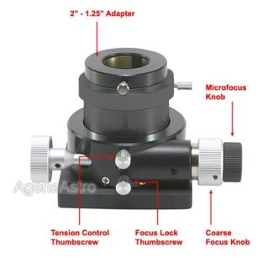

Rationale: A Crayford focuser provides both coarse and fine focusing (or microfocusing) of an object, and operates smoothly. Fine focusing can be a big help for planetary observing if you’re looking for bands on Jupiter or Saturn, as well as for globular clusters because the fine focus allows you to easily “dig through” a cluster to resolve more stars. Smaller aperture telescopes may not have a Crayford focuser available as an option because they don’t capture enough light, and therefore, enough celestial detail to benefit from one.

**Plössl Eyepieces (EPs)**

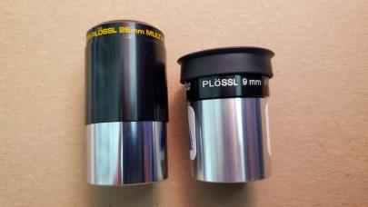

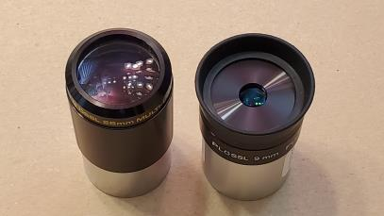

Rationale: Plössls are the best beginning eyepieces because they give decent fields of view with decent eye relief at a reasonable price. (Eye Relief is the distance from the eyepiece glass within which you can see the entire field of view; outside of this distance [roughly ⅔ the focal length of a Plössl EP] you get a reduced field of view or can’t see anything). A new “Dob” should come with a wide field, long focal length EP 20 – 40 mm (for finding objects), and a shorter focal length, higher magnification EP, such as a 9 or 10 mm (for looking at detail in objects). Or, it might be one EP used with a device called a “Barlow lens” which doubles or triples the magnification of the EP inserted into it, so, a single 20 mm EP with a Barlow is like having both a 20 mm and a 10 mm. Another option is a zoom eyepiece that functions as both wide field and high magnification eyepiece ⎯ but not all zoom eyepieces work well in all telescopes.

In any case, a longer focal length EP has a wider field of view, but a lower level of magnification (i.e., a lower “power”) of an image, while a short focal length EP has a much smaller field of view, but much higher magnification (i.e., higher power) of an image. This means a lower power EP is good for searching for objects or viewing objects that have a wider field, while a short focal length EP is good for seeing an object you’ve found in relative close-up.

There are MANY types of EPs, all of which have their pros and cons. Everyone has their favorites and different eyepieces vary in performance depending on telescope, and also depending on the observer’s eyes. One or two decent ones is/are plenty to start. Use of a 25 mm for wide field and 10 mm for close-ups should handle most observing situations. Many of us have additional eyepieces, but they are rarely used.

*NOTE:* In the image above, note that the EP on the left is 26 mm and has a large piece of glass in the top. The EP to the right has a much smaller piece of glass. This EP (the 9 mm) will have a much smaller field of view, so you’ll have to nudge your scope to the west ***a lot*** more often to look at a given object. For non-motorized telescopes, eyepieces with very short focal lengths of 6 mm or less are very difficult to use and are often trying to magnify an image that is not saturated (with light) enough to support the magnification they provide—plus they are very hard to look through and provide an annoyingly tiny field of view. For more on eyepieces and the role they play see:

[https://lovethenightsky.com/telescope-eyepieces-all-you-need-to-know-but-were-afraid-to-ask](https://lovethenightsky.com/telescope-eyepieces-all-you-need-to-know-but-were-afraid-to-ask/) and/or <http://science.howstuffworks.com/telescope6.htm>

**Telescopes for Kids**

Buying a telescope for kids is a difficult decision since there’s a risk they won’t continue to have an interest in space and astronomy, but getting a cheap and unusable telescope is guaranteed to frustrate them.  Any of the first seven telescope models listed in the Specific Recommendations section (below) should be acceptable for kids and cost no more than $310 and can cost as little at $70.  Reflector telescopes on Dobsonian mounts are probably the simplest to use, and are among the toughest.  Try to get the most aperture size you can within your budget. We recommend an aperture of at least 60mm (2.4”).  
  
For children under about 10-11 years old, parental participation will be needed at least for a while to show how to set up and use the telescope, and find things and keep them in view.  Parents are usually a bit more patient when making fine adjustments.  
  
We also have a half-hour YouTube video that gives an overview of features that are Good and Bad when looking for a telescope.  This may be more information than you need for purchasing a telescope for a child, but what’s covered applies to all the telescopes being recommended.  The Telescope Fair Overview video can be viewed at <https://YouTube.com/@wvas>.

**Specific Recommendations**

Specific Recommendations**:** The following telescopes are ordered by manufacturer or distributor.Note that some of the following telescopes may be available with other apertures, mounts, and accessories. The information below was current as of this document’s revision date. Please see the web sites of the manufacturers and vendors for details, included accessories, current pricing, and availability for each model.

During the pandemic, people realized that telescopes are great for an at-home activity. The resulting demand for them, paired with supply chain problems, has caused popular models to be in short supply, especially during the holiday gift-giving season. Things have improved but don’t be surprised if your order is delayed.

|  |  |  |  |  |  |
| --- | --- | --- | --- | --- | --- |
| Telescope Make and Model | Mount Type | Aperture / Focal Length (mm) | Weight (lbs.) | Price | Recommended By |
| [AWB OneSky Reflector](https://shop.astronomerswithoutborders.org/products/awb-onesky-reflector-telescope) | Dob | 130mm (5") / 650 | 17.6 | $250 | *Sky&Telescope* magazine, space.com |
| [Celestron Astro Fi Refractor & Reflector](https://www.amazon.com/Celestron-Refractor-Refracting-Telescope-22201/dp/B01L0EQKR6?th=1) (computerized with Wi-Fi control) | alt-az | 90mm (3.5") / 910  102mm (4”) / 1325  130mm (5.2") / 650 | 17  16  18 | $500  $438  $530 | space.com |
| [Celestron NexStar 130 SLT Reflector](https://www.celestron.com/products/nexstar-130slt-computerized-telescope) (motorized with computer control) | alt-az | 130mm (5.1") / 650 | 18.8 | $640 | WVAS |
| [Celestron NexStar Evolution 8HD SCT with StarSense](https://www.celestron.com/products/nexstar-evolution-8-hd-telescope-with-starsense) | alt-az | 203mm (8") / 2032 | 42 | $2,949 | *Astronomy* magazine |
| [Celestron PowerSeeker Refractor](https://www.amazon.com/Celestron-21036-PowerSeeker-Telescope-Black/dp/B0000UMLYI/ref=sr_1_3?adgrpid=1344703371431645&hvadid=84044170169027&hvbmt=be&hvdev=c&hvlocint=4083&hvlocphy=49220&hvnetw=o&hvqmt=e&hvtargid=kwd-84044384779059%3Aloc-190&hydadcr=27888_14484131&keywords=celestron%2Bpowerseeker%2Baz&qid=1666472600&qu=eyJxc2MiOiIxLjk3IiwicXNhIjoiMC4wMCIsInFzcCI6IjAuMDAifQ%3D%3D&sr=8-3&ufe=app_do%3Aamzn1.fos.006c50ae-5d4c-4777-9bc0-4513d670b6bc&th=1) | alt-az | 60mm (2.4") / 700  70mm (2.8") / 700 | 7  8 | $75  $100 | WVAS |
| [Celestron StarSense Explorer DX 102AZ](https://www.celestron.com/products/starsense-explorer-dx-102az) Refractor | alt-az | 102mm (4”) / 660 | 14.2 | $470 | space.com |
| [Celestron StarSense Explorer DX 130AZ](https://www.celestron.com/products/starsense-explorer-dx-130az) Reflector | alt-az | 130mm (5.1”) / 650 | 18 | $480 | space.com |
| [Explore Scientific FirstLight Refractor](https://www.amazon.com/Explore-Scientific-FL-AR90500AZ-Refractor-Telescope/dp/B0743J26BP) | alt-az | 90mm (3.5") / 500 | ? | $160 | *Astronomy* magazine |
| [Orion Observer II Refractor](https://www.amazon.com/Orion-Observer-Refractor-Telescope-Starter/dp/B077ZS5Q14) | alt-az | 60mm (2.4") / 700  70mm (2.8") / 700 | 4.3  7.4 | $80  $90 | WVAS |
| [Orion SkyQuest XT Classic](https://www.telescope.com/catalog/search.cmd?form_state=searchForm&siteCode=US&keyword=skyquest+xt+classic) | Dob | 152mm (6”) / 1178  205mm (8”) / 1219 | 31.5  39.1 | $450  $650 | WVAS |
| [Orion SkyScanner 100 Reflector](https://www.telescope.com/Orion-SkyScanner-100mm-TableTop-Reflector-Telescope/p/102007.uts) | Dob | 100mm (3.9") / 400 | 6.2 | $130 | *Sky&Telescope* magazine |
| [Orion StarBlast II Reflector](https://www.telescope.com/Orion-StarBlast-II-45-Equatorial-Reflector-Telescope/p/116895.uts) | eq | 114mm (4.5") / 500 | 15 | $180 | *Sky&Telescope* magazine |
| [Orion StarBlast II Reflector](https://www.telescope.com/Orion/StarBlast-II-45-Equatorial-Reflector-and-TD-1-Motor-Drive/rc/2160/p/116990.uts?keyword=starblast%20ii) (motorized) | eq | 114mm (4.5") / 500 | 16 | $240 | *Sky&Telescope* magazine |

|  |  |  |
| --- | --- | --- |
| Suggested Accessories | | |
| **Item** | **Price Range** | **Comments** |
| 10 mm Plössl EP | $25-450 | Brand dependent: most 10 mm Plössls on Amazon are part of sets |
| 25 mm Plössl EP | $30-122 | Brand dependent |
| Crayford Focuser | $73-275 | Feature & brand dependent |
| Green Laser Pointer | $10-40 | Depending on type & strength |
| RACI Finder | $60-178 | Feature & brand dependent |
| Red Dot Finder | $30-40 | Type/Brand dependent |
| Red LED Flashlight | $9-24 | Feature & Brand dependent. |

**Brands of telescopes (alphabetical):**

[Celestron](https://www.celestron.com/)

[Explore Scientific](https://explorescientificusa.com/)

[iOptron](https://www.ioptron.com/)

[Meade Instruments](https://www.meade.com/)

[Orion](https://www.telescope.com/)

[Scientifics Direct](https://www.scientificsonline.com/shop/astronomy)

[Sky-Watcher](http://www.skywatcherusa.com/)

[Takahashi](http://www.takahashiamerica.com/)

[Zhumell](https://www.telescopesplus.com/pages/zhumell-telescopes)

& others

**Some vendors of telescopes & accessories:**

Adorama: <https://www.adorama.com/c/Binoculars-and-Scopes>

Amazon: <https://www.amazon.com/>

Camera Concepts and Telescope Solutions: <http://camera-concepts.shoplightspeed.com/>

Farpoint: <https://farpointastro.com>

High Point Scientific: <https://www.highpointscientific.com/>

Orion: <https://www.telescope.com>

Scope City: <http://www.scopecity.com/>

ScopeStuff: <http://www.scopestuff.com/>

Woodland Hills Camera & Telescopes: <https://telescopes.net/store/>

If you would like to discuss any of these recommendations with us or if you find some other telescopes you’re considering purchasing, please contact us by sending e-mail to [WVASinfo@gmail.com](mailto:WVASinfo@gmail.com).

**Perseverance**

Astronomy is a rewarding hobby, but like most pursuits it requires practice. It often takes three or more nights out with the telescope to really get adept enough to use it successfully. However, it will be well worth the time.